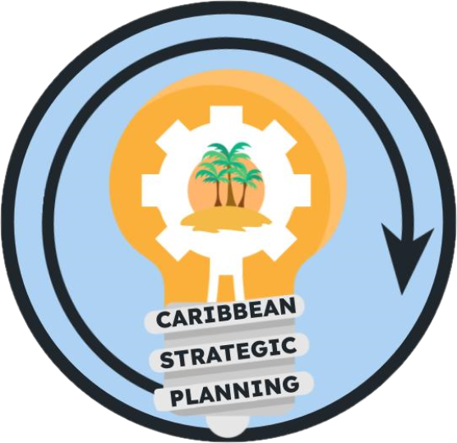Team Charter

Project: Develop socioeconomic data gap team to develop and prioritize data inventory

**Purpose**

**Our purpose is** to identify major socio-economic data gaps and information to improve fisheries management decisions in the U.S. Caribbean.

**Goals**

**Our goals are** to prioritize socio-economic data needs for decision-making in the U.S. Caribbean fisheries, identify available data, and suggest mechanisms and methods for data acquisition efforts. The team will also explore the factors that currently prevent the integration or use of socio-economic data for management decisions in the region and provide guidance on strategies to overcome them.

**Our ideal outcomes include** more fruitful collaborations between natural scientists, particularly stock assessment scientists, and social scientists in the context of the U.S. Caribbean fisheries management; proposed mechanisms to improve stakeholder input in the fisheries decision-making process; and the establishment of systematic socio-economic data collection efforts for the region.

**The deliverables will be**:

1. A list of socio-economic data gaps for which data collection should be prioritized, determined by their usefulness for management decisions in the U.S. Caribbean, such as stock assessment and EBFM efforts.

2. A document including recommendations for methods and approaches for socio-economic data collection to fill said gaps.

3. The creation and initiation of a collaborative resource for sharing available socio-economic data and literature.

**Team**

● *Lead*: Tarsila Seara

● *Members*: Shannon Cass-Calay, Mandy Karnauskas, Juan Agar, Matthew McPherson

● *Stakeholders*: CFMC, CIMAS, DNER/DRNA, DPNR, EBFM TAP, NOAA HQ, NPS, PRSG, QM/CI PSG, SEFSC, SERO, SSC, UPR, USC-A, UVI

● *KSAs*: Economist, Management (SERO), SSRG

**Team Process**

● *Meeting day/time*: 9/6/2023 at 2pm

● *Meeting frequency*: 4-5 weeks

● *Decision-making procedures*: Consensus

● *Team communication*: Zoom for standing or any ad-hoc meetings, group emails for routine communications between meetings, and comments in working drafts placed in team google drive folder.

**Team Norms**

● *Values*:

○ Integrity, reproducibility, transparency, and communication of data

○ Innovation through adaptive management and continuous improvement

○ Respect and trust in data and partnerships

○ Diversity and inclusivity of data sources, data input, communities, and stakeholder ideas

○ Collaboration and cooperation in the collection and dissemination of data

● *Agreements*: The Team agrees to work in an environment of mutual respect where all Team Members will be given an opportunity and encouraged to present ideas and viewpoints. Hand raising will not be needed during google meets as long as team members do not talk over each other.

**Supporting Resources**

● *Google Drive folder*: [Working Groups](https://drive.google.com/drive/folders/1GR0WWtq_eOGT89s0n8p1imwZ1ntcnczN)

● *Project facilitation*: Rachel Banton (rachel.banton@noaa.gov)

● *Process facilitation*: Richard Maclin, Vivian Matter (vivian.matter@noaa.gov), Jenny Suter (jenny.suter@noaa.gov)

**Metrics**

Success will be measured by the development of a document including deliverables 1 and 2, and initiation of deliverable 3.